TAITA TAVETA NATIONAL POLYTECHNIC

DEPARTMENT OF ELECTRICAL AND ELECTRONICS ENGINEERING

MECHATRONIC TECHNICIAN LEVEL 6

PROJECT TITLE: SMART LAUNDRY BASKET FOR HOSPITAL HYGIENE
BY

JAVAN ABONDO OTIENO

REG NO: 0060039T/MCT/6/2024/007

THIS PROJECT IS SUBMITTED IN PARTIAL FULFILMENT OF THE REQUIREMENT FOR THE AWARD OF THE DIPLOMA IN MECHATRONIC TECHNICIAN AT TAITA TAVETA NATIONAL POLYTECHNIC IN THE YEAR 2026

SUPERVISOR: MASIKA STEPHANIE
YEAR: 2026

DECLARATION PAGE
I hereby declare that this project report is based on my original work except for citations and quotations which have been duly acknowledged. I also declare that it has not been previously submitted for any other academic award.
Name: Javan Abondo Otieno
REG No: 0060039T/MCT/6/2024/007
Signature: _________________
Date: __________________

SUPERVISOR APPROVAL
I, the undersigned, certify that this project report has been prepared under my supervision and is submitted with my approval.
Supervisor: Masika Stephanie
Signature: _________________
Date: __________________

DEDICATION PAGE
This project is dedicated to my parents, family members, and friends whose encouragement, prayers, and support enabled me to complete my studies and successfully undertake this project. Not to forget my good friend Elina a great supporter indeed, my supervisor Masika Stephanie whose constant help, encouragement, insights and support towards me achieving the goals never faded. My classmates like Elisha Jilo, Humphrey Nzai, Skibo and other all whose constant help moved me.

ACKNOWLEDGEMENTS PAGE
I wish to express my sincere appreciation to my supervisor Md. Masika Stephanie for her continuous support, professional guidance, and valuable advice during the development of this project.
I also extend my gratitude to the lecturers and technical staff of the Department of Electrical and Electronics Engineering at Taita Taveta National Polytechnic for providing the knowledge and practical skills necessary for completing this project.
I also want to thank Md. Emilly whose continuers encouragement moved me a lot.
Finally, I thank my family and friends like Elina, Elisha and my classmates as a whole for their encouragement and moral support throughout the project period.

ABSTRACT
Hospital hygiene plays a crucial role in preventing the spread of infections among patients and healthcare workers. Traditional laundry baskets used in hospitals require manual handling, which increases the risk of contamination and exposure to harmful microorganisms. Additionally, contaminated laundry can produce unpleasant odors and harmful gases if not handled properly.

This project presents the design and development of a Smart Laundry Basket for Hospital Hygiene that integrates automation and sensor technology to improve sanitation and safety in healthcare environments. The system uses an ultrasonic sensor to detect the presence of clothes and automatically open the lid of the basket without physical contact. A relay-controlled pump is used to spray disinfectant mist inside the basket to reduce microbial contamination. A gas sensor monitors the presence of harmful gases and unpleasant odors produced by contaminated laundry.
The system is controlled using an Arduino Uno microcontroller, which processes sensor signals and controls the operation of actuators such as the pump and lid mechanism. The proposed system reduces human contact with contaminated laundry, improves infection control, and enhances hygiene standards in hospitals.
The Smart Laundry Basket is a cost-effective and practical solution that can be implemented in hospitals, clinics, laboratories, and other healthcare facilities

TABLE OF CONTENTS
Contents
DECLARATION PAGE 2
SUPERVISOR APPROVAL 2
DEDICATION PAGE 3
ACKNOWLEDGEMENTS PAGE 4
ABSTRACT 5
TABLE OF CONTENTS 6
CHAPTER ONE 8
1.1 Introduction 8
1.2 Background of the Study 9
1.3 Problem Statement 10
1.4 Objectives 11
1.6 Justification 12
1.8 Budget and Resources 13
CHAPTER TWO 14
LITERATURE REVIEW 14
2.1 Introduction 14
2.2 Smart Waste and Laundry Management Systems 14
2.3 Sensor Technology in Automation 14
2.4 Microcontrollers in Mechatronic Systems 15
CHAPTER THREE 16
METHODOLOGY 16
3.1 Research Design 16
3.2 Data Collection Methods 16
3.3 Tools and Equipment 16
CHAPTER 4: 17
System Analysis and Requirement Modeling 17
1. Overview 17
2. Current System Analysis 17
3. Proposed System Analysis 18
4. Requirement Analysis 18
5. System Modeling 19
5.2 Data Flow Diagram (DFD) 19
5.3 System Block Diagram 20
CHAPTER FIVE 21
SYSTEM DESIGN 21
1. Overview of the System Design 21
2. Hardware Design 22
CHAPTER SIX 25
SYSTEM IMPLEMENTATION 25
1. Overview 25
2. Hardware Implementation 25
2.2 Ultrasonic Sensor 25
2.3 Relay Module and Disinfectant Pump 26
2.4 Basket Housing 26
Disinfectant Activation: 27
4. System Integration 27
5. System Testing and Verification 27
CHAPTER SEVEN 28
LIMITATIONS, CONCLUSIONS AND RECOMMENDATIONS 28
7.1 Limitations 28
7.2 Conclusion 29
7.3 Recommendations 31
REFERENCES 33
APPENDICES 34
Appendix A – Arduino Code 34
Appendix B – Circuit diagram 37

CHAPTER ONE

1.1 Introduction
Hospitals produce large volumes of laundry every day, including bed sheets, blankets, patient gowns, surgical drapes, and staff uniforms. These materials may carry harmful microorganisms such as bacteria, viruses, and fungi, which can cause infections if not handled properly. Maintaining high levels of hygiene during the collection, storage, and transportation of hospital laundry is therefore critical.
Traditional laundry baskets require manual handling, which exposes healthcare workers to potential contamination. Opening the basket lid, depositing contaminated materials, and transporting the laundry all involve physical contact with surfaces that may contain harmful pathogens.
With advancements in mechatronics and automation technology, it is possible to develop smart systems that improve hygiene and reduce human contact with contaminated materials. Sensors, microcontrollers, and automated actuators can be integrated to design intelligent systems that enhance safety and efficiency.
The Smart Laundry Basket for Hospital Hygiene is an automated system designed to minimize human contact with contaminated laundry while improving sanitation practices. The system uses an ultrasonic sensor to detect the presence of clothes and automatically open the lid. It also uses a relay-controlled pump to spray disinfectant mist inside the basket and a gas sensor to monitor unpleasant odors or gases produced by dirty laundry.
By combining sensing technology, microcontroller programming, and mechanical design, this project demonstrates how mechatronic systems can be used to improve hygiene and infection control in healthcare facilities.

1.2 Background of the Study
Healthcare facilities require strict hygiene practices to prevent infections. Hospital laundry management is an important aspect of infection control because contaminated materials can carry pathogens that spread diseases.
Traditional laundry collection systems rely on manual handling, which increases the risk of cross-contamination between patients, healthcare workers, and the environment. Furthermore, contaminated laundry may produce unpleasant odors and gases due to microbial decomposition.
The development of smart automated systems has opened new opportunities for improving hygiene management. Modern sensor technologies such as ultrasonic sensors and gas sensors can detect environmental conditions and trigger automated actions.
By integrating sensors with microcontrollers like the Arduino Uno, it becomes possible to design systems that automatically respond to environmental changes. Such systems can improve safety, reduce manual labor, and enhance operational efficiency.
The Smart Laundry Basket is designed based on these principles, integrating sensors and actuators to create a hygienic and automated laundry handling solution.

1.3 Problem Statement
Despite advancements in hospital hygiene practices, many healthcare facilities still rely on manual laundry handling systems. These systems present several challenges:
1. Healthcare workers must touch the laundry basket lid, increasing the risk of contamination.
2. Contaminated laundry may accumulate bacteria and produce unpleasant odors.
3. Lack of automatic disinfection mechanisms during laundry collection.
4. Poor monitoring of environmental conditions inside the basket.
These challenges highlight the need for a smart automated system that can reduce human contact, improve hygiene, and ensure safer handling of hospital laundry.

1.4 Objectives
General Objective
To design and develop a Smart Laundry Basket for Hospital Hygiene using sensor-based automation.
Specific Objectives
1. To design an automatic lid mechanism controlled by an ultrasonic sensor.
2. To develop a disinfectant spraying system using a relay-controlled pump.
3. To integrate a gas sensor for odor detection.
4. To implement an Arduino Uno microcontroller for system control.
5. To improve hospital hygiene and reduce contamination risks.

Scope
The project focuses on designing and developing a prototype smart laundry basket using:
• Arduino Uno
• Ultrasonic sensor
• Gas sensor
• Relay module
• Pump and mist sprayer
• Mechanical housing
Limitations
The system may be limited by:
• Sensor detection range
• Power supply limitations
• Budget constraints
• Environmental factors affecting sensors

1.6 Justification
The project addresses a real problem in healthcare environments. By reducing direct contact with contaminated laundry and introducing automatic disinfection, the system improves hygiene and infection control. The solution is affordable, practical, and applicable in hospitals and clinics.

1.7 Project Risks and Mitigation
Risk Mitigation
Sensor failure Regular calibration
Pump malfunction Use quality pump
Power failure Backup power system
Electronic damage Protective housing

1.8 Budget and Resources
Item Quantity Estimated Cost
Arduino Uno 1 1200
Ultrasonic Sensor 1 500

Relay Module 1 400
Mini Pump 1 800
Disinfectant Tank 1 150
Housing Materials 1 400
Wires and Components - 1 250

CHAPTER TWO

LITERATURE REVIEW
This chapter reviews previous studies and technologies related to smart waste management, sensor automation, and hospital hygiene systems.

2.1 Introduction
A literature review examines existing research and technologies relevant to the project. It helps identify current solutions, limitations, and opportunities for improvement

2.2 Smart Waste and Laundry Management Systems
Smart waste bins and laundry systems have been developed to improve hygiene and efficiency in public spaces and healthcare facilities. These systems often use sensors to detect objects and automate operations.
Ultrasonic sensors are commonly used in smart bins to detect objects and automatically open lids.

2.3 Sensor Technology in Automation
Sensors play a key role in automation systems by detecting environmental changes and sending signals to control systems.
Ultrasonic Sensors
Used for distance measurement and object detection

2.4 Microcontrollers in Mechatronic Systems
Microcontrollers such as Arduino are widely used in mechatronic systems due to their flexibility, affordability, and ease of programming.
The Arduino Uno serves as the brain of the system, processing sensor data and controlling actuators.

2.5 Disinfection Systems
Disinfection systems using mist spraying are commonly used to eliminate bacteria and viruses. In healthcare environments, disinfectant spraying can significantly reduce microbial contamination.

CHAPTER THREE

METHODOLOGY
This chapter describes the methods used to design and develop the Smart Laundry Basket.

3.1 Research Design
The project uses a prototype development approach, where a working model of the system is designed and tested.

3.2 Data Collection Methods
Information was collected through:
• Literature review
• Observation of hospital hygiene practices
• Consultation with technical experts

3.3 Tools and Equipment
The project used:
• Arduino IDE software
• Electronic components
• Mechanical tools
• Testing instruments

CHAPTER 4:

System Analysis and Requirement Modeling

1. Overview
The purpose of this chapter is to analyze the current manual laundry handling system in hospitals, identify its shortcomings, and define the requirements for the Smart Hospital Laundry Basket for Hygiene system. Proper system analysis and requirement modeling ensure that the final design meets hospital needs for efficiency, safety, and hygiene.

2. Current System Analysis
2.1 Manual Laundry Handling
In most hospitals, laundry collection and disposal are done manually:
Soiled linen is collected in large bins or carts.
Staff manually handle contaminated laundry to transport it to washing areas.
Disinfection is performed separately in washing stations.

Limitations of the Current System:
Risk of Infection: Manual handling increases exposure to pathogens.
Inefficiency: Staff must spend significant time opening lids, sorting laundry, and spraying disinfectants manually
Uncontrolled Hygiene: There is no automated disinfectant application, leading to inconsistent hygiene.
High Labor Dependency: Requires multiple staff members for large volumes of laundry.

3. Proposed System Analysis
The Smart Hospital Laundry Basket automates critical parts of the laundry handling process:
Lid opens automatically when laundry is detected.
Disinfectant pump sprays a fine mist over the laundry.
The system minimizes direct contact, ensuring hygienic disposal.
This system addresses the limitations of the current manual process by improving hygiene, efficiency, and safety.

4. Requirement Analysis
4.1 Functional Requirements
Functional requirements define what the system must do:
Laundry Detection:
The ultrasonic sensor must detect laundry placed inside the basket.
Automated Lid Operation:
The system should automatically open the lid when laundry is detected.
Disinfectant Spraying:
The relay-controlled pump should spray disinfectant for a predefined duration.
System Reset:
After completing the spraying cycle, the system should return to standby mode.
4.2 Non-Functional Requirements
Non-functional requirements define the quality attributes of the system:
Hygiene:
Components should be easy to clean and resistant to contamination.
Durability:
The basket and electronic components should withstand frequent use.
Safety:
Low-voltage electronics and relay isolation ensure safe operation.
Reliability:
The system should operate consistently under normal hospital conditions.
Maintainability:
Components should be easily accessible for maintenance and repair.

5. System Modeling

5.2 Data Flow Diagram (DFD)
Level 0 (Context Diagram):
|
Input: Laundry placement
|
Process: Smart Laundry Basket detects laundry and activates pump
|
Output: Disinfected laundry and ready-to-use basket
|
Level 1 (Detailed DFD):
|
Input: Ultrasonic sensor signals laundry presence.
|
Process: Arduino processes signal and triggers relay.
|
Output: Pump sprays disinfectant; lid operation occurs.

5.3 System Block Diagram

Components:
Input: Ultrasonic sensor

Processing unit( Arduino uno)

Output: Relay + Disinfectant Pump and servo motor

CHAPTER FIVE

SYSTEM DESIGN

1. Overview of the System Design
The Smart Hospital Laundry Basket for Hygiene system was designed to improve the collection and handling of hospital laundry in a hygienic and efficient manner. The system integrates both hardware and software components to automate the detection and monitoring of hospital linens placed in the laundry basket.
The design focuses on minimizing direct contact with contaminated materials, improving hygiene standards, and ensuring that hospital staff are properly guided during the laundry disposal process. The system operates using sensors, a microcontroller, and a display unit to monitor the laundry basket and provide feedback to the user.

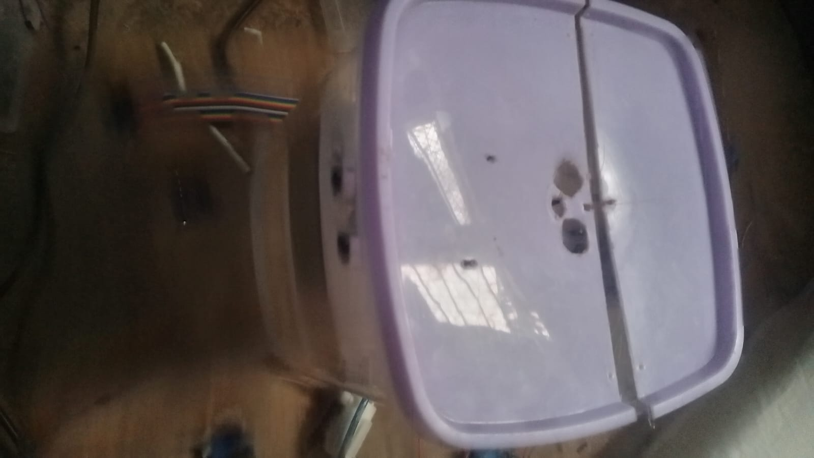

2. Hardware Design
The hardware design consists of the physical components that make up the smart laundry basket system. These components work together to detect laundry placement, process information, and provide output to the user.
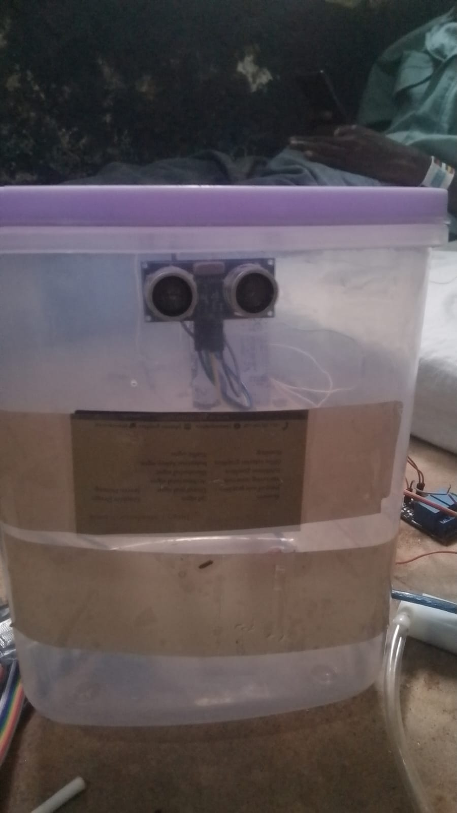

a) Microcontroller
The microcontroller acts as the main control unit of the system. It processes signals received from the sensors and controls other components such as the display and indicators. The microcontroller ensures that the system responds appropriately when laundry is placed inside the basket.

b) Ultrasonic Sensor
The ultrasonic sensor is used to detect the presence of laundry items inside the basket. It measures the distance between the sensor and the laundry surface. When the basket begins to fill up, the sensor sends signals to the microcontroller, which then processes the information and determines whether the basket is approaching full capacity.
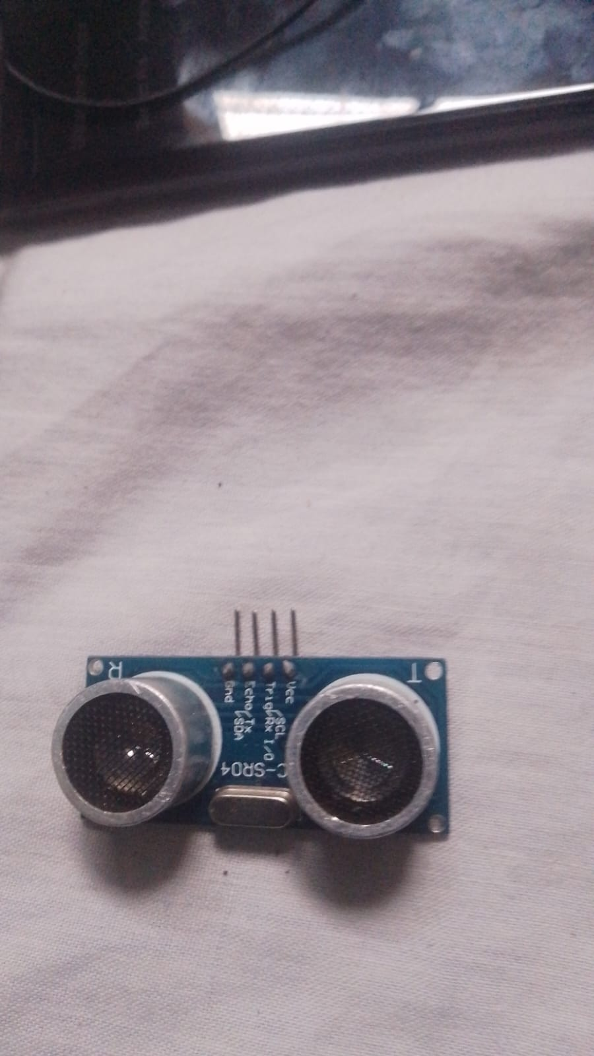
C} Power Supply
The system is powered by a stable power source that provides electrical energy to all electronic components. The power supply ensures that the microcontroller, sensors, and display operate reliably.
e) Basket Structure
The physical laundry basket is designed using materials that are durable, easy to clean, and resistant to contamination. The structure must be strong enough to support hospital linens while maintaining hygiene standards.
3. Software Design
The software component controls the overall operation of the system. A program is written and uploaded into the microcontroller to manage the interaction between the sensor, display, and other components.
1.The program follows a sequence of operations:
2.The system initializes when power is supplied.
3.The ultrasonic sensor continuously monitors the basket.
4.When laundry is placed inside, the sensor detects the change in distance.
5.The microcontroller processes the signal.
This software ensures that the system operates automatically and efficiently without requiring complex user interaction.
4. System Operation
The smart laundry basket operates through a simple automated process. When hospital staff place laundry items in the basket, the ultrasonic sensor detects their presence. The sensor sends this information to the microcontroller, which then processes the data and displays messages on the LCD screen.
If the basket reaches its capacity, the system can alert users to stop adding more laundry and notify staff responsible for collection. This process helps prevent overflow and ensures proper management of hospital laundry.

CHAPTER SIX

SYSTEM IMPLEMENTATION

1. Overview
The Smart Hospital Laundry Basket for Hygiene was developed to reduce manual handling of hospital laundry and improve infection control in hospital environments. Hospitals generate large volumes of soiled linens that may carry bacteria and other pathogens, creating a risk for healthcare workers during manual laundry collection.
This system automates lid opening and disinfectant spraying using an ultrasonic sensor, Arduino Uno microcontroller, and relay-controlled pump, ensuring minimal contact with potentially contaminated laundry. The system was implemented as a functional prototype, integrating both hardware and software components to provide hands-free operation and maintain hygiene standards.
The implementation process involved hardware assembly, software programming, integration, and testing of all components.

2. Hardware Implementation
2.1 Microcontroller: Arduino Uno
The Arduino Uno serves as the main controller of the system. It receives input signals from the ultrasonic sensor and activates the relay to control the disinfectant pump.
Function: Processes sensor inputs and controls the pump according to programmed instructions.
Installation: Mounted on a secure board inside the basket housing with proper insulation.
Power Supply: Powered using a stable 5V DC supply to ensure reliable operation of all components.

2.2 Ultrasonic Sensor
The ultrasonic sensor detects the presence of laundry in the basket.
Working Principle: The sensor emits high-frequency sound waves and measures the time taken for the echo to return from the surface of the laundry.
Function: When laundry is detected within a preset range, it triggers the Arduino to operate the lid and activate the disinfectant pump.

2.3 Relay Module and Disinfectant Pump
The relay module acts as a switch to safely control the disinfectant pump, which requires higher current than the Arduino can provide.
Function: When the Arduino detects laundry, it signals the relay to close the circuit and power the pump.
Operation: The pump sprays a fine mist of disinfectant over the laundry for a predetermined duration to sanitize it.
Safety: The relay protects the microcontroller from high current and ensures stable operation of the pump.

2.4 Basket Housing
The basket housing serves both structural and protective functions:
Durability: Constructed with robust materials capable of holding hospital laundry.
Protection: Shields electronic components from moisture, accidental damage, and contamination.
Functionality: Proper alignment of the ultrasonic sensor and pump ensures accurate detection and effective disinfectant coverage.

3. Software Implementation
The system software was developed in the Arduino IDE and uploaded to the Arduino Uno. The program controls the sequence of operations to automate the laundry handling process.
Software Logic:
System Initialization:
Upon power-up, the Arduino initializes the ultrasonic sensor, relay, and pump. All outputs are set to safe default states.
Laundry Detection:
The ultrasonic sensor continuously monitors the basket for the presence of laundry. When an object is detected within the defined range, the Arduino interprets the signal as a valid input.

Disinfectant Activation:
Upon detection, the Arduino triggers the relay to activate the pump. Disinfectant is sprayed over the laundry for a predefined duration to ensure sanitization.
System Reset:
After spraying, the relay is turned off, and the system returns to standby mode, ready to detect the next batch of laundry.

4. System Integration
All hardware and software components were integrated to form a fully functional prototype:
The ultrasonic sensor provides input to the Arduino.
The Arduino processes the signal and activates the relay.
The relay switches the pump to spray disinfectant.
The basket housing ensures structural support and protects the electronics.
Proper wiring, secure mounting, and calibration of the sensor ensured smooth operation. The ultrasonic sensor was calibrated to detect standard hospital laundry volumes effectively.

5. System Testing and Verification
The prototype underwent thorough testing to verify performance:
Laundry Detection: Various sizes and quantities of laundry were placed in the basket. The ultrasonic sensor consistently detected the items.
Pump Operation: The relay successfully powered the disinfectant pump for the programmed duration.
The tests confirmed that the system performs its intended function reliably, providing hands-free operation and effective disinfectant application.

CHAPTER SEVEN

LIMITATIONS, CONCLUSIONS AND RECOMMENDATIONS

7.1 Limitations
Despite the successful design and implementation of the Smart Hospital Laundry Basket for Hygiene system, several limitations were encountered during the development and testing of the project. These limitations may affect the performance, scalability, and practical application of the system in real hospital environments.

1. Limited Prototype Design
The project was developed as a prototype model, which means it was designed primarily for demonstration and testing purposes. As a result, the system may not fully represent the large-scale operational requirements of a real hospital laundry management system.

2. Limited Sensor Capability
The system relies on basic sensors to detect the presence of laundry items. These sensors may not accurately measure the exact quantity or weight of the laundry inside the basket. In a real hospital setting, more advanced sensors such as load cells or weight sensors may be required to improve accuracy.

3. Power Dependency
The smart laundry basket system depends on a continuous power supply to function effectively. In situations where there is power interruption, the system may temporarily stop functioning unless a backup power source is provided.

4. Environmental Conditions
Hospital environments may contain moisture, high temperatures, or chemical disinfectants that could affect the performance of electronic components over time. Without proper protective casing and industrial-grade materials, the system may experience reduced durability.
5. Limited Data Storage and Monitoring
The current system operates as a standalone unit and does not store large amounts of operational data or provide remote monitoring capabilities. This limits the ability of hospital administrators to track laundry management trends or monitor multiple baskets simultaneously.

6. Budget Constraints
The development of the project was conducted under limited financial resources, which restricted the use of more advanced technologies such as IoT connectivity, cloud data storage, and automated communication systems.

7. Limited Testing Environment
The system was tested under controlled conditions rather than in an actual hospital environment. Therefore, real-world factors such as heavy usage, staff interaction, and operational pressure were not fully evaluated.

7.2 Conclusion
In conclusion, the Smart Hospital Laundry Basket for Hygiene project was successfully designed and developed to improve the management and handling of hospital laundry. Proper handling of hospital linens is an important aspect of maintaining hygiene and preventing the spread of infections within healthcare environments. Traditional laundry collection methods often involve manual handling, which may increase the risk of contamination and inefficiency. The smart laundry basket system was therefore developed to provide a more hygienic, efficient, and automated solution.

The system integrates modern technologies such as sensors, microcontrollers, and display systems to detect the presence of laundry and provide necessary instructions to users. By automating certain processes, the system helps minimize unnecessary contact with contaminated materials and ensures that laundry is handled in a more organized and controlled manner. This contributes to improved infection prevention and better management of hospital hygiene standards.
During the development of the project, both hardware and software components were successfully integrated. The system was designed to monitor laundry placement, provide user feedback through a display unit, and improve the efficiency of hospital waste and laundry handling. Testing of the system demonstrated that the smart laundry basket can effectively support healthcare workers in maintaining cleanliness and hygiene in hospital environments.
Furthermore, the project demonstrates how smart technologies and automation can be applied in healthcare facilities to improve operational efficiency and safety. The development of such systems highlights the importance of innovation in solving real-world problems, especially those related to public health and sanitation.
Although the current prototype provides a functional solution, there are opportunities for further improvements such as integration with Internet of Things (IoT) systems, enhanced sensors, and centralized monitoring capabilities. These improvements would make the system even more efficient and suitable for large healthcare institutions.Overall, the Smart Hospital Laundry Basket for Hygiene project provides a practical and innovative approach to improving hospital laundry management. The system contributes to better hygiene practices, increased efficiency, and safer working conditions for healthcare workers.

7.3 Recommendations
1. Integration of IoT Technology
Future versions of the smart hospital laundry basket should incorporate Internet of Things (IoT) technology. This would allow the system to send real-time data about the laundry basket status to hospital management systems or mobile devices. For example, when the basket becomes full, a notification could automatically be sent to the laundry department. This would improve efficiency and reduce delays in collecting contaminated hospital linens.

2. Use of Advanced Sensors
The current system can be improved by using more advanced sensors such as weight sensors or load sensors. These sensors would help determine the exact amount of laundry inside the basket rather than relying only on presence detection. This would make the system more accurate in monitoring laundry capacity and prevent overfilling.

3. Integration with Hospital Management Systems
The smart laundry basket could be connected to the hospital management information system. This would allow hospital administrators to track laundry usage, monitor hygiene practices, and manage hospital resources more effectively. Data collected from the system could also help in planning laundry schedules and improving operational efficiency.

4. Improved Safety Features
Additional safety features should be included to ensure proper handling of contaminated hospital linens. For example, the system could include automatic lid closing mechanisms to prevent exposure to harmful bacteria or infectious materials. This would help maintain a higher level of hygiene within hospital environments.

5. Use of Durable and Hygienic Materials
The physical structure of the laundry basket should be constructed using durable, rust-resistant, and easy-to-clean materials such as stainless steel or antimicrobial plastic. These materials would help maintain hygiene standards and ensure the system can withstand frequent use in busy hospital environments.
6. Power Backup System
Hospitals require continuous operation of equipment; therefore, future systems should include a backup power supply, such as rechargeable batteries or an uninterrupted power supply (UPS). This would ensure the smart laundry basket continues functioning even during power interruptions.

7. User Training and Awareness
For the system to function effectively, hospital staff should receive proper training on how to use the smart laundry basket system. Awareness programs can also be conducted to educate healthcare workers about the importance of proper laundry handling and hygiene practices.

8. Expansion for Large Healthcare Facilities
Future improvements should consider designing larger or networked versions of the smart laundry basket for large hospitals. Multiple smart baskets could be connected to a central monitoring system, allowing the hospital to manage laundry operations more efficiently across different departments

REFERENCES
1.Hussin, E., Jian, W. J., Sahar, N., Zakariya, A., Ridzuan, A., Suhana, C., & Hong, L. W. (2022).
A Healthcare Laundry Management System using RFID System.
The research explains how RFID technology can track hospital linens from washing to storage, improving hygiene and inventory management.

2.Seiko Tags Technology (2023).
Intelligent Hospital Fabric Management: RFID Laundry Management System.
This system uses RFID tags to track hospital clothes and linens throughout their washing and storage lifecycle, improving hygiene control.
3.SmartX HUB (2021).
Intelligent Control of Hospital Linens and Uniforms using RFID.
RFID-based systems allow hospitals to track, sort, and monitor laundry automatically while reducing manual handling and infection risk.

4.World Health Organization (WHO). (2018).
Safe Management of Wastes from Health-Care Activities.
WHO guidelines explain safe handling of contaminated materials such as hospital linen to prevent infections.

APPENDICES

Appendix A – Arduino Code
#include <Servo.h>

Servo myServo;

// Pin definitions
const int trigPin = 10;
const int echoPin = 11;
const int servoPin = 9;
const int pumpRelay = 6; // relay controlling the pump

long duration;
float distance;

const float threshold = 15.0;

bool cycleRunning = false; // prevents repeated triggering

// Function to run pump in pulse mode
void runPumpPulse() {

unsigned long startTime = millis();

while (millis() - startTime < 10000) { // run for 10 seconds

digitalWrite(pumpRelay, LOW); // Pump ON
delay(300);

digitalWrite(pumpRelay, HIGH); // Pump OFF
delay(300);
}

digitalWrite(pumpRelay, HIGH); // ensure pump is OFF
}

void setup() {

pinMode(trigPin, OUTPUT);
pinMode(echoPin, INPUT);
pinMode(pumpRelay, OUTPUT);

digitalWrite(pumpRelay, HIGH); // relay OFF

myServo.attach(servoPin);
myServo.write(90); // initial position

Serial.begin(9600);
}

void loop() {

// Trigger ultrasonic sensor
digitalWrite(trigPin, LOW);
delayMicroseconds(2);

digitalWrite(trigPin, HIGH);
delayMicroseconds(10);
digitalWrite(trigPin, LOW);

duration = pulseIn(echoPin, HIGH);
distance = duration * 0.034 / 2;

Serial.print("Distance: ");
Serial.println(distance);

if (distance > 0 && distance <= threshold && !cycleRunning) {

cycleRunning = true;

// Open lid
myServo.write(180);
delay(4000); // time to drop clothes

// Close lid
myServo.write(90);
delay(1000);

// Run disinfectant pump
runPumpPulse();

// Allow collection
delay(5000);
}

// Reset system only when person leaves
if (distance > threshold && cycleRunning) {
cycleRunning = false;
Serial.println("System Reset");
}

delay(200);
}

Appendix B – Circuit diagram